Docker Installation Guide

Student handout

# Installation for windows

## Step 1

* Download the Docker Desktop installer from the [url](https://www.docker.com/products/docker-desktop/)

## Step 2

* Double-click Docker Desktop Installer.exe to run the installer. By default, Docker Desktop is installed at C:\Program Files\Docker\Docker.

## Step 3

* Tick both checkboxes then click ok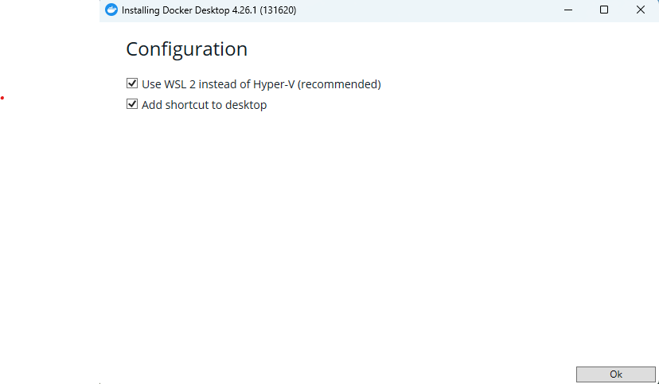

## Step 4

* Then click Close and r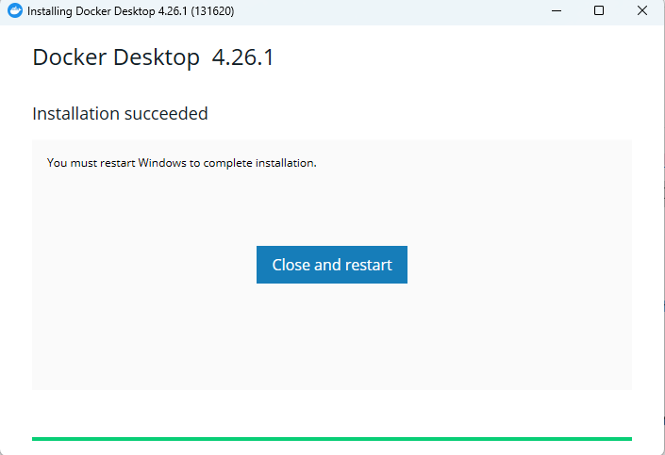

## Step 5

* After restarting the machine, accept the service.

## Step 6

* Select the 1st radio button, "Use recommended settings," then click Finish.
* Then click finish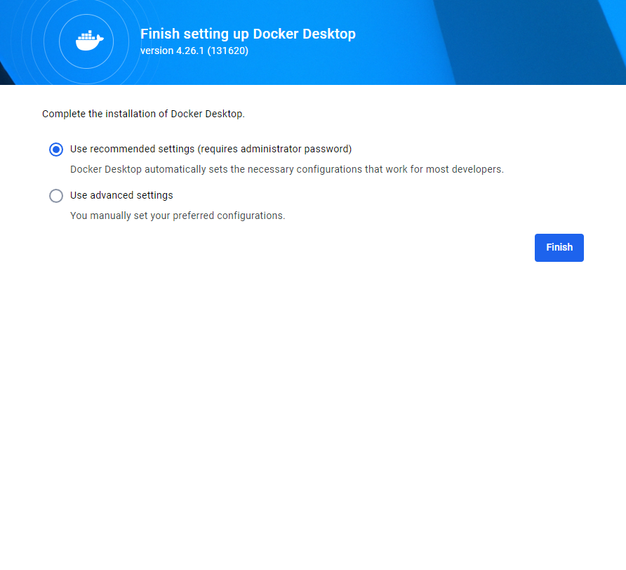

## Step 7

* Click continue without signing in



## Step 8

* Click Skip

## Step 9

* Check docker is installed
  + Open cmd
    - docker -v

## Step 10

* Check docker compose is installed
  + Open cmd
    - docker-compose --version

# Reference url

<https://docs.docker.com/desktop/install/windows-install/>

<https://www.docker.com/products/docker-desktop/>